**Linux**

Difference between Linux and Windows ?

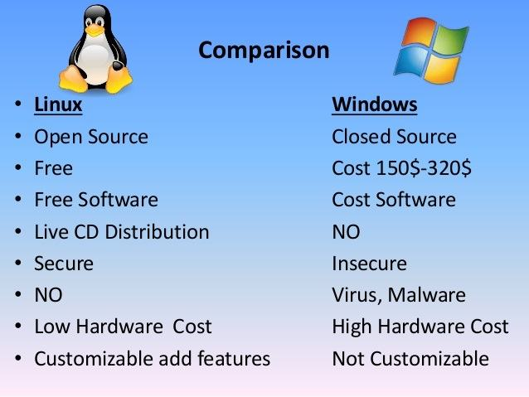

Windows 🡺 GUI (Graphical User Interface)

Linux 🡺 CLI (Command Line Interface)

Linux Basic commands :

1) ls: Lists the contents of a directory.

Command : ls

2) cd: Changes the current directory.

Command : cd /path/to/directory

3) pwd: Prints the current working directory.

Command : pwd

4) mkdir: Creates a new directory.

Command : mkdir new_directory

5) rm: Removes files or directories.

Command : rm file_name

rm -r directory_name

6) cp: Copies files or directories.

Command : cp source_file destination_file

cp -r source_directory destination_directory

7) mv: Moves or renames files or directories.

Command : mv old_name new_name

mv file_name /path/to/destination

8) cat: Concatenates and displays the content of files.

Command : cat file_name

9) sudo: Executes a command with superuser(root) privileges.

Command : echo "Hello, World!"

echo "Hello, World!" > file_name

10) tar: Archives multiple files into a single file and optionally compresses it.

Command : tar -czvf archive_name.tar.gz /path/to/directory

tar -xzvf archive_name.tar.gz # To extract an archive

11) vi : To create a file

Command : vi name_of_the_file